**Finalized Group name:** **JSPE-Techies**

**Group members: (**in alphabetical order)

| **Member name** | **Email** | **Phone** |
| --- | --- | --- |
| Jayani Sumanka Gerine | jayanis@umich.edu | 248-979-4748 |
| Pallavi Dabade | pallavid@umich.edu | 734-355-8539 |
| Raksha Varahamurthy | rakshav@umich.edu | 313-213-2853 |
| Surya Subramani | suryasss@umich.edu | 313-415-4759 |

**Introduce each team member:** biography of each team member

Jayani Sumanka Gerine:

My name is Jayani Sumanka Gerine and I’m pursuing a Masters in Computer and Information Science. I’m an experienced professional with nearly six years of experience in operations management, process management and client relationship management. I have over 2 years’ experience working as an L3 support for a health care product of a leading pharmaceutical company. Previously, I have worked nearly 4 years in the financial services industry specializing in process management and business intelligence.

Pallavi Dabade

My name is Pallavi Dabade. I am pursuing a Master in AI and this is my first semester. I have 14+ years professional experience as Full stack Software Engineers and Dev lead for small teams. I got the opportunity to work for BCBSM, Infosys, HPE and recently with General Motors. I worked on diverse platforms and technologies but mostly worked on full stack web development projects. At this point, learning AI to upgrade my skill set to align with current market trends.

Raksha Varahamurthy :

My name is Raksha Varahamurthy and I am a highly motivated Master's graduate in Artificial Intelligence with a strong academic background and practical experience in machine learning. With 3 years of experience in the field, I've had the opportunity to work with a wide range of clients and projects. Throughout my career, I've had the privilege of working on some exciting projects to solve real world problems using deep learning techniques.

Surya Subramani :

I am Surya Subramani, a masters student with 2 years of experience in Artificial Intelligence and 7 years of freelancing design experience. The perfect blend of creativity and technical mind makes me unique. Currently I am working as a student Graphic design under the ECE department along with my art passion. My Research passion lies towards Reinforcement Learning and Computer Vision and aims to automate the entire graphic design process with human touch. I will serve as an AI integrator and UI designer for this project.

**Identify one team member who will serve as the main contact for the instructor:**  
  
 Pallavi Dabade

**Team agreement:**

* **Methods of communication**  
   Google Meet , Gchat, whatsapp.
* **Expected communication response times** 24hrs
* **Meeting attendance**   
   All meetings are mandatory for all team members.

Weekly meeting -Every Friday at 10.30 am

If necessary we will have more sessions (based on everyone’s schedule )

* **Running meetings**  
   Face to Face : Google Meet as scheduled

Minutes Of the Meeting : all members contribute

Meeting Notes : all members contribute

* **Meeting preparation**  
   Meeting agenda : Define before meeting by all team members
* **Version contro**l   
   Code and documentation will be pushed to Github

All push must be approved by all team members.

* **Division of work** Based on agreement of all team members
* **Submitting assignments**

All members will review and finalize document

Final document will be sent to the professor and TA in PDF format

Document will be submitted by as per team agreement

* **Contingency planning**

**If a team member drops out –**

Inform professor and TA about situation

work will distribute in the remaining team members  
**If a team member consistently misses meetings -**

as per agreement all meetings are mandatory

consistent missing meeting will result in informing professor and TA

and decision by team to continue/drop team member

**If a team member is academically dishonest –**

We will discuss and confirm first and we can report to professor

**Tools to be used for project development and implementation -**

Jira for Project Management

GitHub for code management

**Project domain and proposal:**

**TechBlog for University of Michigan Students**

**Intended use of the system:**

**Who will use system:**

The system will be used by individuals affiliated with the University of Michigan who meet the following criteria:

* University of Michigan Students: This includes undergraduate and graduate students currently enrolled at the University of Michigan.
* University of Michigan Faculty: This includes professors, instructors, researchers, and other academic staff members who are employed by the University of Michigan.
* Anyone with a University of Michigan Email ID: Individuals who possess an official University of Michigan email address, which typically includes students, faculty, and staff.
* Anyone with a Unique Name: It appears that individuals with unique names associated with the University of Michigan may also use the system. This could include alumni, former students, or others who have a specific connection to the university

**How system will be used :**

Umich users can login to the system and use it to search top 5 articles based on their search keyword and selected preferences.

**Overall functionality:** what will the system do, how will the system help its users accomplish their tasks. (3 pts)

**What will the system do:**

Developing a comprehensive platform that allows end users (students and professors) to search Top 5 articles based on their set of preferences which are derived using AI Algorithms.

**How will the system help its users accomplish their tasks:**

Utilizing an existing database or creating one and implementing AI-driven features to enhance user experience and content discoverability.

Applied natural language processing (NLP) techniques for content recommendation for top 5 articles.

Facilitated collaboration and knowledge sharing within the University of Michigan academic community.

**Main components of the system:**

**Handwritten Diagram for break down of high level System Component overview**

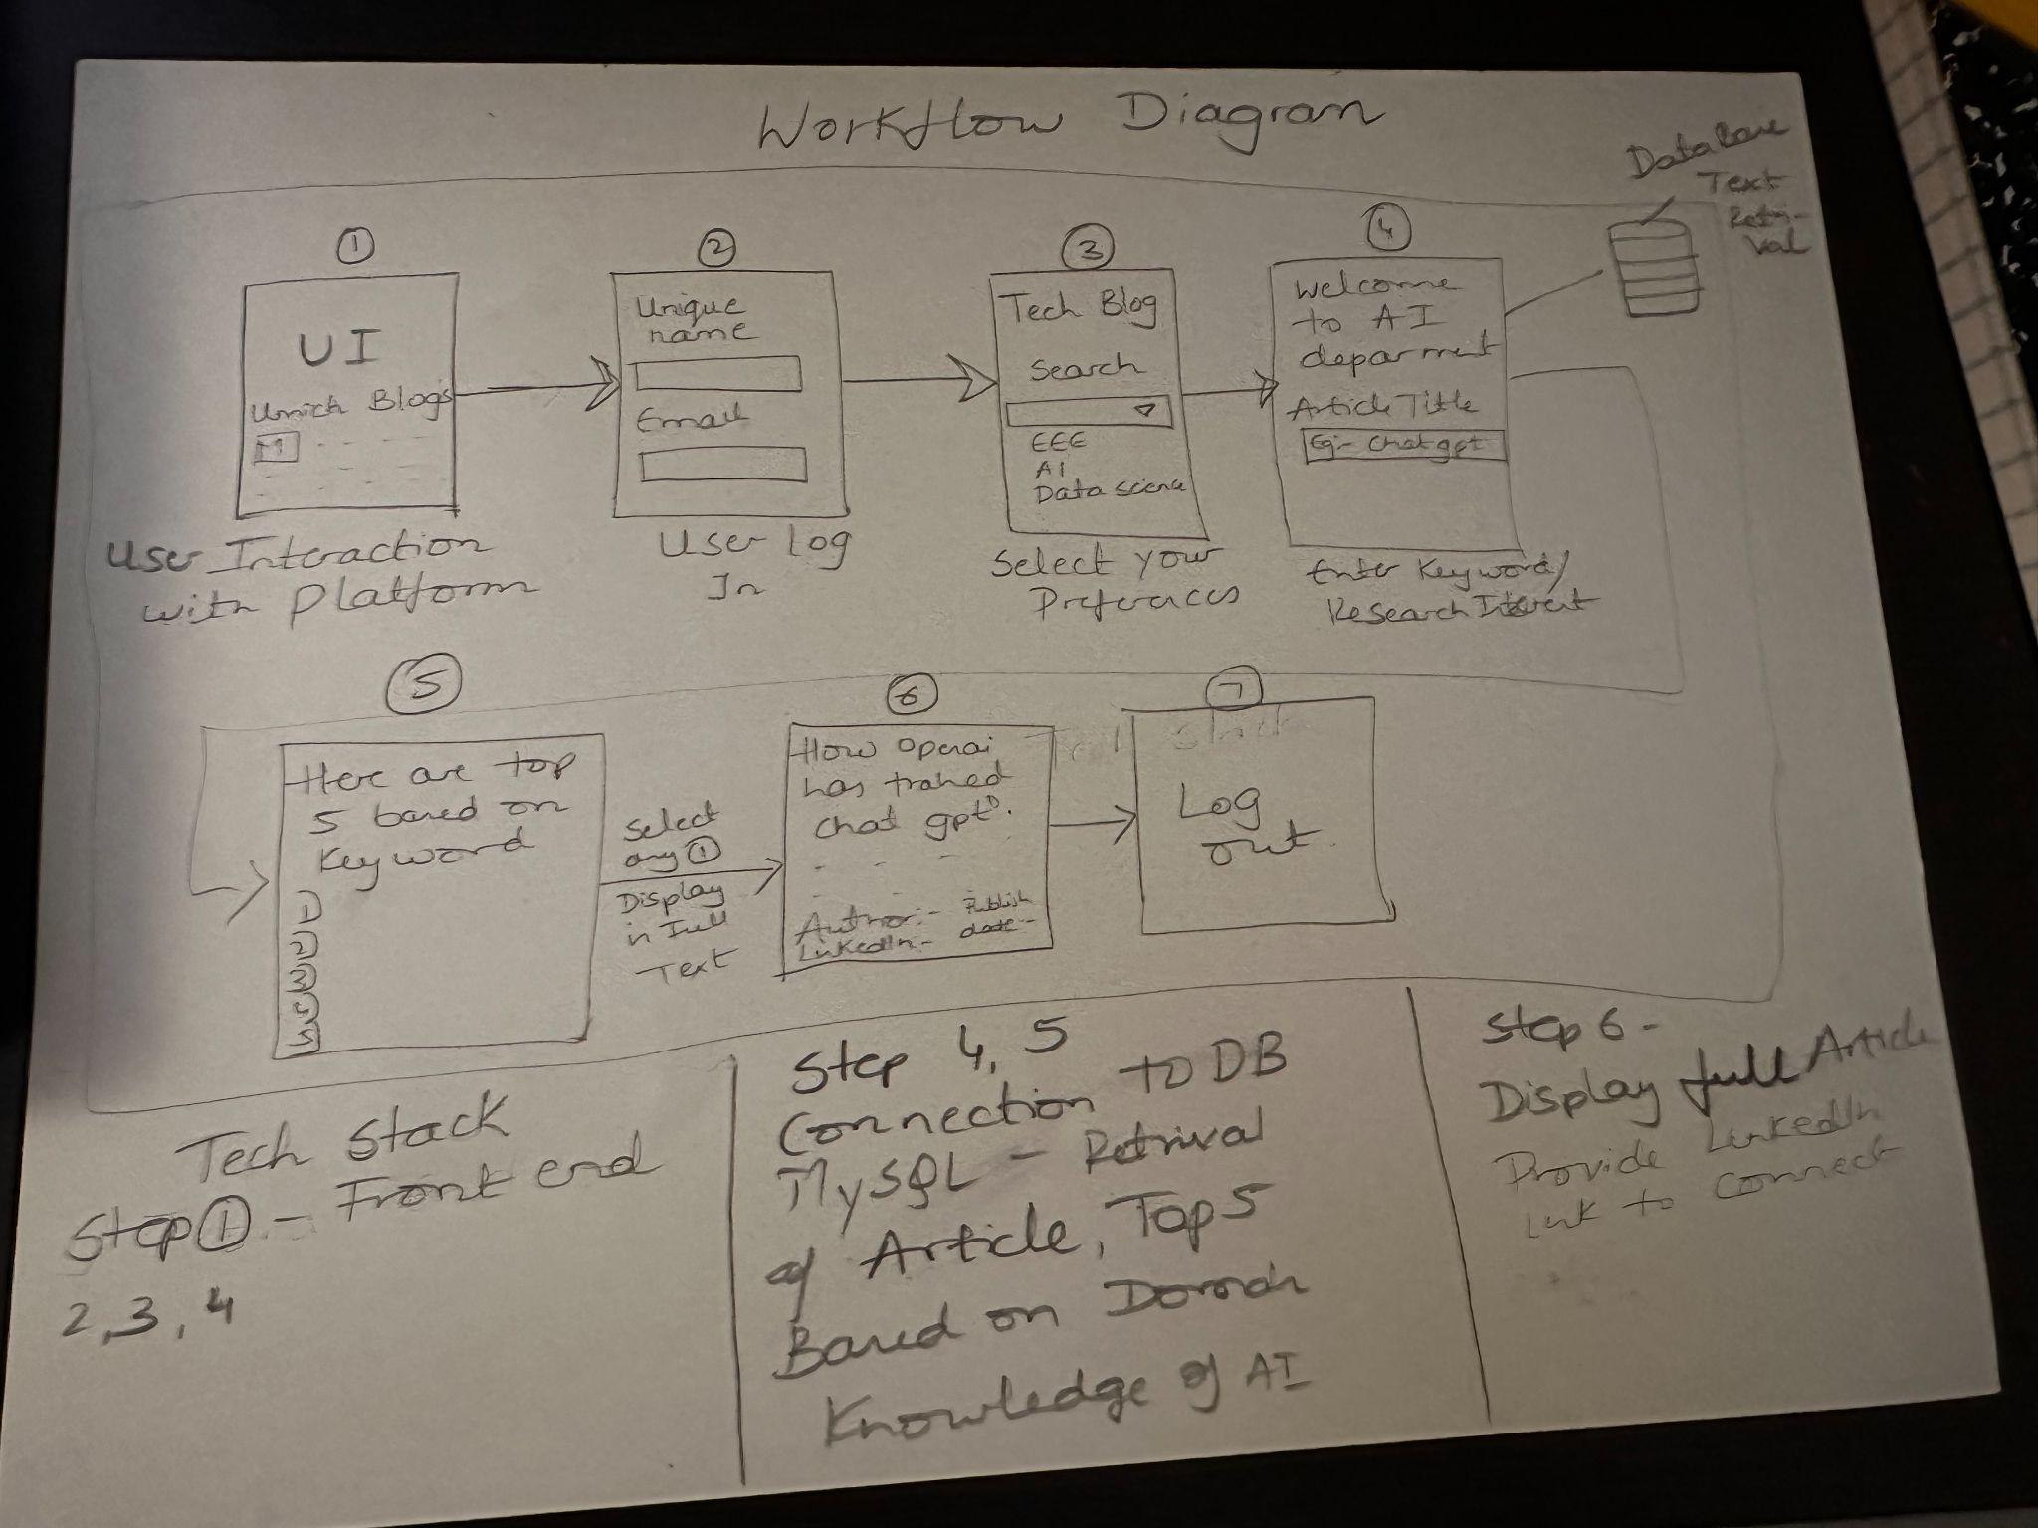  
  
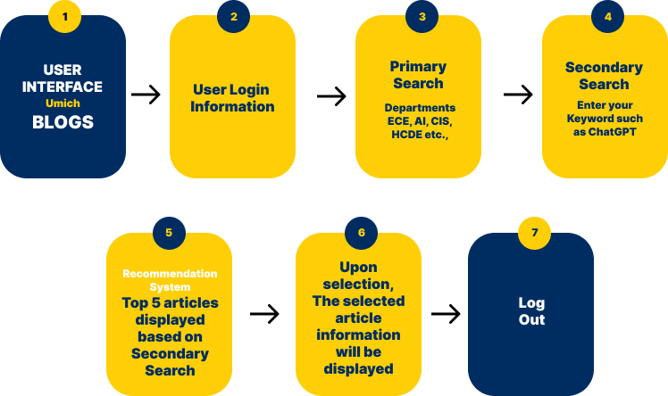

**Break down of Logical Component of System**

1. **User Interface (UI) Component:**
   * **Rationale:** The UI component is the user-facing part of the system, responsible for presenting content and enabling user interactions. It's crucial for providing an intuitive and interactive experience to system users, including students and professors.
2. **Database Component:**
   * **Rationale:** The database component searches user-generated content. It serves as the system's data backbone, ensuring data consistency, retrieval, and storage efficiency.
3. **AI-Driven Features Component:**
   * **Rationale:** This component includes the AI algorithms and models responsible for enhancing user experience and content discoverability. It applies natural language processing (NLP) techniques for content recommendation, These AI-driven features help users discover relevant content and engage with the platform more effectively.
4. **Web Development Component:**
   * **Rationale:** The web development component is responsible for building and maintaining the platform's web application. It utilizes web development technologies and frameworks to create a user-friendly and responsive interface. This component ensures that the platform functions seamlessly across various devices and browsers.